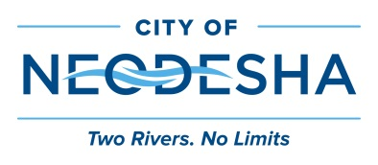 | 1407 N. 8th St. P O Box 336 Neodesha, Kansas 66757

SPECIAL CALL FOR SPECIAL MEETING OF BOARD OF COMMISSIONERS

Neodesha, Kansas
July 18, 2022

To the Board of Commissioners:

The Board of Commissioners will hold a Special Call meeting Monday, July 18, 2022 at
12:00 p.m., at City Hall, for the following purpose:

- 2023 Budget Review
- Approve Publication for 2023 Budget; Notice of Public Hearing
- Executive Session: Non-elected Personnel

Commission Signatures:

